**Дата**: 31.03.2025

**Клас**: 5-АБ

**Предмет**: англійська мова

**Тема:** Аналіз ТДР №6. Узагальнення і систематизація знань з теми :«Давай веселитися!».

**Мета:** формувати навички вживання лексичних одиниць по темі; удосконалювати навички читання, аудіювання й усного монологічного мовлення; розвивати пізнавальні інтереси учнів; виховувати інтерес до самостійного пошуку потрібної інформації, а також загальну культуру учнів.

**Вчитель**: Руда Д.В.

Хід уроку

1.Greeting

Good afternoon, guys! I’m pickled pink to see you. Are you ready to start our lesson? All set?

2. Повторення

Повторити Irregular verbs .

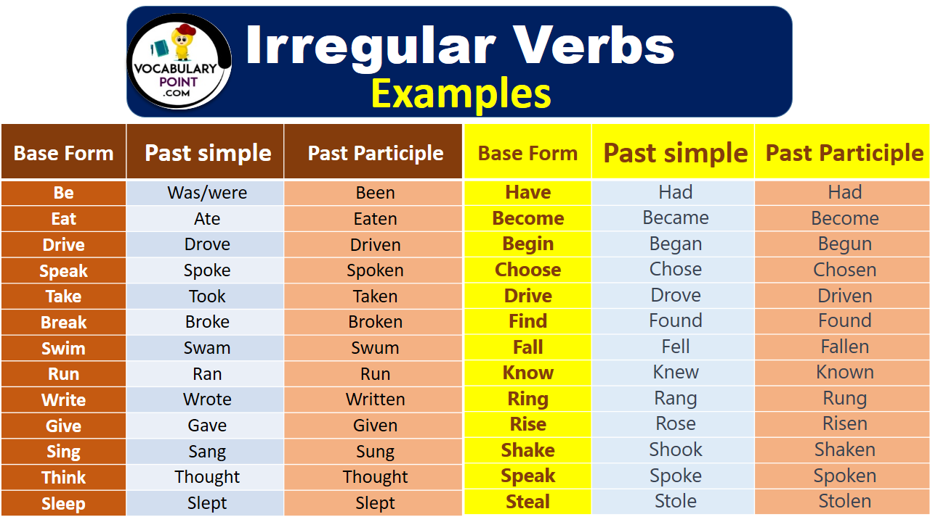

***Вивчити словник (бути готовим до слоникового диктанту) :***

*Careful-обережно (кеафул)*

*Slippery-слизько (сліпері)*

*To put on- одягати (пут он)*

*Overcast: covered with clouds; no sun is visible.- похмуро, сонця нема (овекаст)*

*"Under the weather": feeling ill or in low spirits. (e.g., "I'm feeling a bit under the weather today, so I'll stay home from work.")- мати погане самопочуття ( анде за везе)*

.

*Drizzle-мряка(дрізл)*

*Showers- a [short](https://dictionary.cambridge.org/dictionary/english/short" \o "short) [period](https://dictionary.cambridge.org/dictionary/english/period" \o "period) of [rain](https://dictionary.cambridge.org/dictionary/english/rain" \o "rain) or [snow](https://dictionary.cambridge.org/dictionary/english/snow" \o "snow)*

*Downpour- a lot of [rain](https://dictionary.cambridge.org/dictionary/english/rain" \o "rain) in a [short](https://dictionary.cambridge.org/dictionary/english/short" \o "short) [time](https://dictionary.cambridge.org/dictionary/english/time" \o "time) (дайн пор)*

*Flood-повінь(флад)*

*Hail-град(хейл)*

*Sleet-мокрий сніг(сліт)*

*Snowflake-сніжинка(сноуфлейк)*

*Blizzard-хуртелиця (блізард)*

*Mild: moderate in temperature; neither hot nor cold- помірний, м’який (майлд)*

*"Every cloud has a silver lining": every bad situation has some positive aspect to it. (e.g., "I lost my job, but I found a better one soon after. Every cloud has a silver lining.")- нема лиха без добра( ідіома)*

*To expect-очікувати(експект)*

*To report-повідомити(ріпот)*

*Chilly-прохолодний(чілі)*

*To get cold-холоднішати*

*It`s raining cats and dogs-сильно дощити (ідіома)*

*They cancelled the football game because it was raining cats and dogs.*

3. Wаrm up / Listening

Уважно слухати аудіо трек і дати відповідь на питання вчителя <https://www.youtube.com/watch?v=UI33OLKd-rU> .

4. Speaking

Did you enjoy your last vacation? (How was your vacation?)

How do you feel after a long vacation?

How many days was your vacation?

How much money did you spend on your last vacation?

Did you encounter any problems during your vacation?

How did you resolve them?

Did you have a part-time job during the holidays?

Did you have any bad experiences?

Did you meet any interesting people? Cn you tell me about them.

Did you notice any cross-cultural differences during your vacation?

Did you study during the vacation? If so, what did you study?

How was your trip?

Why did you visit the place(s) you went to?

How did you get there?

Why did you choose the means of transportation that you chose?

How much luggage did you take?

Would you take the same or different equipment next time?

In what ways did you obtain real satisfaction when you were on vacation?

Was the place you went to very different from where you live?

What were the women like?

What were the men like?

Were people friendly?

Did you stay in a hotel?

What was the daily rate?

What historical sites did you visit and what did you learn?

What interesting people did you meet? Tell me about them.

What souvenirs did you buy?

What was the best food you ate during your vacation?

What was the most enjoyable thing that you did during your vacation?

What was the most interesting thing that you did during the vacation?

What was the most interesting thing you did during the holiday?

5. Writing

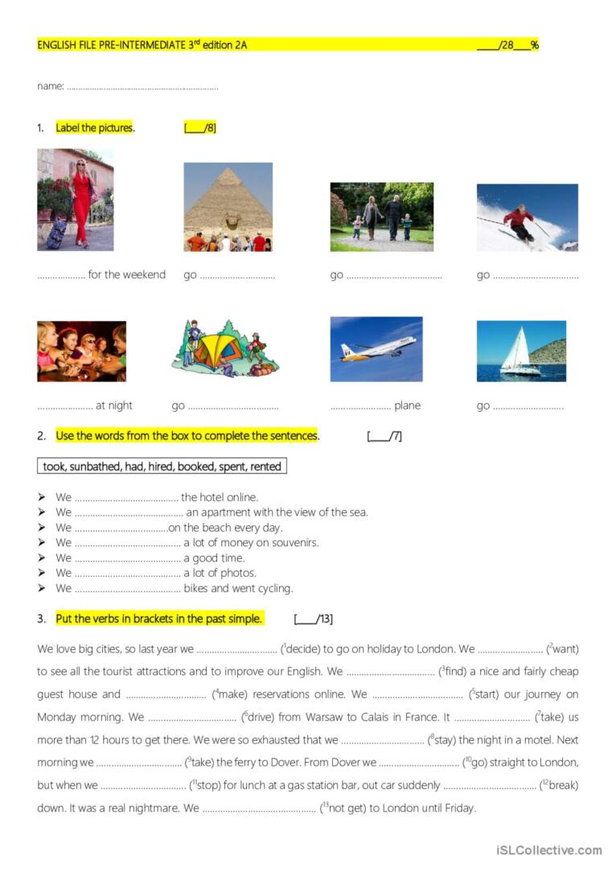

Повторення past simple and irregular verbs <https://www.liveworksheets.com/w/en/english-second-language-esl/327437#google_vignette>

6. Homework

1. Виконати тільки вправу 1 письмово в зошитах (робота з текстом). <https://en.islcollective.com/english-esl-worksheets/grammar-topic/past-simple-tense/test-a1-holidays-version-b-students-with-special-needs/93040>

2. Повторити слова в словнику .